**1. Introduction:**

* Lora is actually a unique proprietary modulation format (phi layer)
* The Lora protocol is a physical layer wireless component
* If you ask what is Lora it does not actually describe anything above the physical layer (RF medium) of the OSI layers.
* Semtech acquired the Lora RF technology and they will give license to others
* LoraWan: MAC layer , open standard maintained by Lora Allilance

**2. RF basic:**

* A Lora Signal starts with a preamble signal which has constant ramp chirp inside.
* Actually the number symbols in a preamble signal = number of chirps / number of peaks of the ramp signal.
* When a preamble signal is detected by the lora modem the modem gets locked on to the preamble signal and then a reverse chirp is signaled to denote the end of the signal . After this data transmission begins. The receiver modem is a demodulator too.

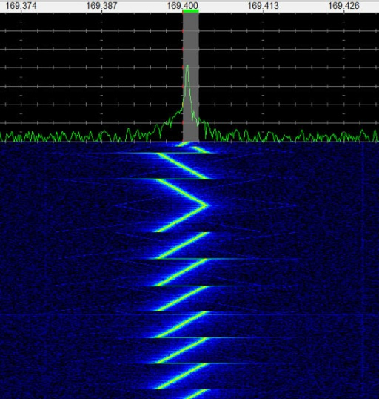 signal detect 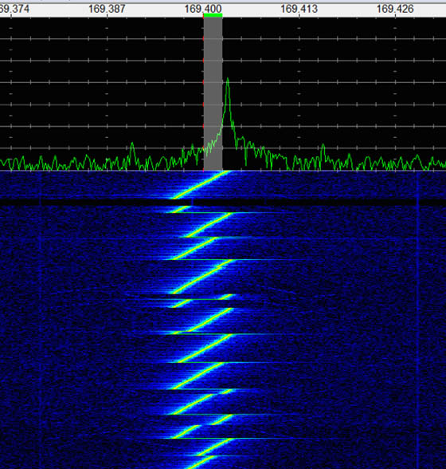 signal demodulate

* “Another powerful feature of LoRa is the ability to demodulate several “orthogonal” or simultaneous signals at the same frequency, assuming they have different chirp rates. This function is supported by the SX1301 chip from Semtech. “- I think this kind of chip is used in the gateway as gateway needs to listen to many nodes and signals may come simultaneously. This is quite obvious because then a gateway can support many devices and build a very large network.
* In the datasheet, LoRa chirp rates are called “spreading factors,” with higher spreading factors denoting slower chirps.
* LoRa RF physical layer uses a form of spread spectrum modulation.
* The fact that only low data rates are used, and low levels of overall data transfer means that low bandwidths are required. A variety of bandwidths are available: 7.8 kHz; 10.4 kHz; 15.6 kHz; 20.8 kHz; 31.2 kHz; 41.7 kHz; 62.5 kHz; 125 kHz; 250 kHz; 500 kHz. The required bandwidth can be selected according to the data requirements as well as the link conditions.
* The power level used within LoRa RF physical layer is adaptive. The power level used is dependent upon the data rate needed, link conditions etc. An algorithm is used to determine the required power level - the transmitted power is normally backed off a little from the maximum needed to support fast communications and in this way the battery life is maximised and network capacity maintained.
* The communication between different end-devices and gateways utilises several different frequency channels and it uses different data rates.
* The choice of the data rate is a balance between communication range and message duration, i.e. the rate at which the required data can be sent.
* The use of the chirp spread spectrum technology enables communications with different data rates not interfere with each other. In this way a set of "virtual" channels is created which increases the capacity of the gateway.

**3. Operating Frequencies:**

The LoRa wireless system makes use of the unlicensed frequencies that are available worldwide. The most widely used frequencies / bands are:

* 868 MHz for Europe
* 915 MHz for North America
* 433 MHz band for Asia

Using lower frequencies than those of the 2.4 or 5.8 GHz ISM bands enables much better coverage to be achieved especially when the nodes are within buildings. Although the sub-1GHz ISM bands are normally used, the technology is essentially frequency agnostic and can be used on most frequencies without fundamental adjustment.

But the problem is each country has its own rules about the sub GHz spectrum uses In fact, many countries have added

Special caveats that make standardization nearly impossible. Until this issue is resolved, there is no globally available band for LPWAN technologies like there is at the 2.4 GHz level (for Bluetooth and WiFi).But you know its BD they will make things complex obviously -_- <http://www.btrc.gov.bd/sites/default/files/radio_frequency_charges.pdf> so why don’t we pay as we use wifi @2.4GHz ?

Question: So what is the unlicensed band in Bangladesh ? or is there none ?

Interestingly In August 2015, the GSMA (Groupe Speciale Mobile Association)—a group made up of mobile operators—announced that it plans on standardizing LPWAN technology on a licensed spectrum by early 2016. This push has received endorsements and backing from companies like“AT&T, Bell Canada, China Mobile, China Telecom, China Unicom, Deutsche Telekom, Etisalat, KDDI, NTT DOCOMO, Ooredoo, Orange, Singtel,Telecom Italia, Telefonica, Telenor, Telstra and Vodafone,”

**4. Building the Lora Network:**

Lora RF

Node

Application server

App key

Node

Cellular/wired

Gateway

Node

Network server

Network key

Application Server

Application Server

Node

Node

Node

Node

Gateway

**4.1 Node:** , the nodes are the sensing elements and are typically in a star-of-stars topology with gateways. Communication to end point nodes is generally bi-directional, but it is also possible to support multicast operation, and this is useful for features such as software upgrades and the like or other mass distribution messages.

**4.1.a Types of nodes:**

|  |
| --- |
| * ***Class A - bi-directional end-devices:***   LoRaWAN class A endpoint devices provide bidirectional communications. To achieve this, each endpoint transmission is followed by two short downlink receive windows.  LoRa Class A operation provides the lowest power option for end points that only require downlink communication from the server shortly after the end-device has sent an uplink transmission. Downlink communications from the server at any other time wait until the next scheduled uplink time. |
| * ***Class B - bi-directional end-devices with scheduled receive slots:***   LoRa Class B devices provide the Class A functionality and in addition to this they open extra receive windows at scheduled times. To achieve the required synchronisation from the network, the endpoint receives a time synchronized Beacon from the gateway. This allows the server to know when the end-device is listening. |
| * ***Class C - bi-directional end-devices with maximal receive slots:***   LoRa Class C devices provide nearly continuously open receive windows. They only closed when the endpoint is transmitting. This type of endpoint is suitable where large amounts of data are needed to be received rather than transmitted. |

**4.2 LoRa gateway *:***

* The gateway receives the communications from the LoRa endpoints and then transfers them onto the backhaul system(network server and application server). This part of the LoRa network can be Ethernet, cellular or any other telecommunications link wired or wireless. The gateways are connected to the network server using standard IP connections. On this way the data uses a standard protocol, LoRa gateways may often be co-located with a cellular base station.
* Gateways within the same network require synchronization
* Gateway working basic info: Communication between end-devices and gateways is spread out on different frequency channels and data rates. The selection of the data rate is a trade-off between communication range and message duration.

**4.3 Server:**   The LoRa network server manages the network. The network server acts to eliminate duplicate packets, schedules acknowledgement, and adapts data rates.

**4.4 Application server:** this is truly up to you how you want to market your lora network.

**4.5 Network Architecture:**

* LoRaWAN network architecture is typically laid out in a star-of-stars topology (star won vs mesh in WAN)
* gateways are a transparent bridge relaying messages between end-devices and a central network server in the backend.
* The network server manages the data rate and RF output for each end-device individually by means of an adaptive data rate (ADR) scheme that is typically updated once every 24 hours
* The lora network is designed primarily for uplink-only applications with many endpoints or applications where only a few downlink messages are required.  (Limited either by application or by number of endpoints)
* Lora can provide timestamp to devices at microsecond accuracy

**5. Application:**

* Smart Watch
* Smart Parking
* Environmental monitoring
* Waste management?
* Street Lightning?
* Asset tracking
* Postpaid based Utility meters mainly water and gas meters <https://www.youtube.com/watch?v=FDZVxUkl8uA>
* Flood monitoring
* Railway Level crossing
* Garage door opener
* Smoke detection

**6. Interesting projects around Lora:**

* Maybe CISCO is making home based router which will have lora module inside may be the router will work as a gateway
* Amsterdam Beacon Mile <https://www.youtube.com/watch?v=w7yF1ONDp7A>
* UK Calderdale Flood Sensor Network <https://www.youtube.com/watch?v=TxMpNsS-oro> [built by things network hardwares]

**7. Existing Market products**

**7.1 Lora Chip manufactures: (Node)**

* Microchip <http://www.microchip.com/wwwproducts/en/RN2483>
* Semtech <http://www.semtech.com/wireless-rf/lora.html> [has a concentrator chip also (gateway)]
* niceRf <http://www.nicerf.com/product_146_136.html> [actually uses semtech chips]

semtech ships are lower in price than microchip

**7.2 Gateway:**

* CISCO 910 industrial router <http://www.cisco.com/c/en/us/products/collateral/routers/900-series-industrial-routers/datasheet-c78-732129.html>

its obvious that new technology devices cost would be very much so The Things network has come up with lora products which are comparatively low . its all open software and open hardware but its actually for development and these are based on Microchip’s Lora modules

* <https://shop.thethingsnetwork.com/index.php/product/the-things-gateway/>
* <https://shop.thethingsnetwork.com/index.php/product/the-things-uno/>
* similarly Froggyfactory sells development alike devices like the things network based on semtech chips
* <http://www.froggyfactory.com/froggy/index.php>
* <http://www.multitech.com/brands/multiconnect-conduit>

**7.3 Lora based LPWAN solution Selling Companies:** who are selling network services (Server + Application server) part of Lora

* <https://www.link-labs.com/>
* <https://www.actility.com/technology/>
* <https://www.loriot.io/>
* <http://www.froggyfactory.com/froggy/>

**8. The All wanted Location tracking topic:**

Geo location is a part of the Lora Standard . and sagemcom is a company working on it .

Basic of location tracking of lora : At the physical layer the radio signal used by LoRa is somewhat closed to a radar signal, thanks to its Chirp Spread Spectrum (CSS) technology. The antenna Gateway can very precisely detect the arrival of the signal emitted from the device,“ explained  Thierry Lestable.   
  
“based on that we use a technology called DTOA (difference time of arrival) very similar to existing technologies in the cellular world: each base station records the time of arrival of the signal from the device and a position is calculated from that.

Semtech says resolution could be from 10m to 100m but sagemcom says it could be more precise and they are working on a protocol what the named is femtoLora

Guess what one company has already announcing a product based on it <https://www.youtube.com/watch?v=x4Ic92efLY8> don’t know about it’s current state though looking like they are marking their footstep on a technology which will see light after 2-3 years . they are smart as they have not disclose Lora in their product they are calling it free rf . to use it you need to buy their Home base station which is actually a compact gateway and already they are have covered the bay area <http://www.iotatracker.com/howitworks> Now as i said location tracking based on Lora technology is quite tough and they are selling a product right now !!!! have a look at LinkLabs statement on this topic <https://www.link-labs.com/lora-localization/> I assume it could be a market hype only So this topic need more study obviously.

**9. Security of Lora Wan:**

<https://www.youtube.com/watch?v=iZOfGGCw90M>

TODO